Microsoft Graph Explorer Guide for M365 Group Creation Restriction

Microsoft Graph Explorer: Guide for M365 Group Creation Restriction

Note
Fast Track: Adding Exceptions to an Already Blocked System
This guide covers the entire setup from scratch. However, if your Office 365 tenant already has a general restriction blocking everyone from creating sites, all you need to do to allow a specific group (while keeping everyone else blocked) is:
- Complete Step 2 to get the unique ID of the group you want to allow (e.g. CF_Lideres).
- Skip directly to Step 6: Update an Existing Configuration (The Correct Method) to inject that group ID into the existing Microsoft rule securely.
If you are setting this up for the very first time, read the full document step-by-step.
This guide provides a highly detailed, untechnical walkthrough to restrict Microsoft 365 Group creation (which also blocks Teams and SharePoint site creation) using the Microsoft Graph Explorer.

Step 1: Access and Login to Graph Explorer
Navigate to the following website:
https://developer.microsoft.com/en-us/graph/graph-explorer
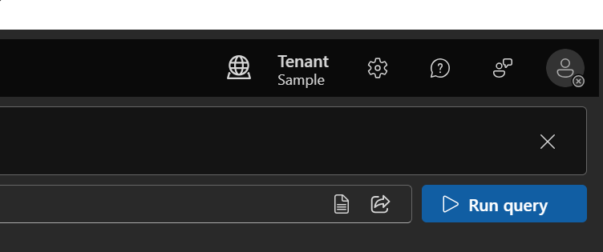
Image: The main landing page of the Microsoft Graph Explorer.
Click on the "Sign In" button on the left side menu to authenticate with your administrator account.
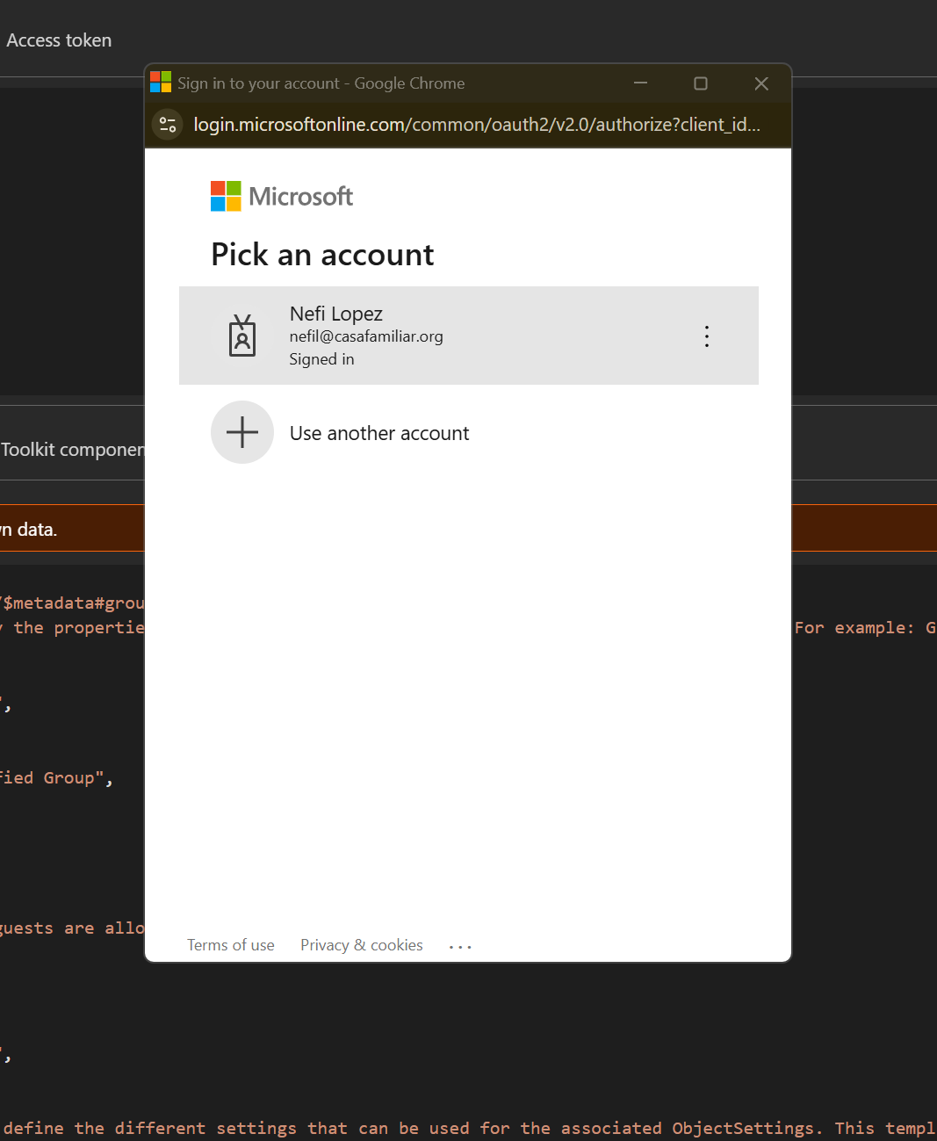
Image: The Sign In button located on the top left corner.
After successfully logging in, your profile picture and account name will appear on the left, and the workspace will be ready to execute commands:
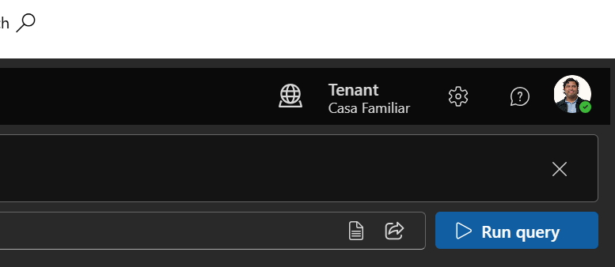
Image: The Graph Explorer interface after a successful login, showing your account details on the left pane.

Step 2: Get the Security Group ID (Optional)
If you plan to block site creation for everyone EXCEPT a specific group (e.g., the CF_Lideres or Leadership team), you need to get the unique ID of that group first.
In the Graph Explorer address bar at the top, execute the following GET query:
GET https://graph.microsoft.com/v1.0/groups?$filter=displayName eq 'CF_Lideres'
Example response you will receive at the bottom screen:
{
"id": "9860c313-b518-4563-a6e3-0de7952319b3",
"deletedDateTime": null,
"classification": null,
"createdDateTime": "2025-10-31T05:07:11Z",
"description": "C level + Lideres",
"displayName": "CF_Lideres",
"securityEnabled": false
}
Locate the "id" field in the response. In this example, the value is:
9860c313-b518-4563-a6e3-0de7952319b3
Copy and save this ID. You will use it later to specify who is exempt from the creation block rule.

Step 3: Get the Correct Setup Template
Before creating a block rule, you need to find the official Microsoft template that controls M365 groups.
Call this endpoint in the address bar:
GET https://graph.microsoft.com/v1.0/groupSettingTemplates
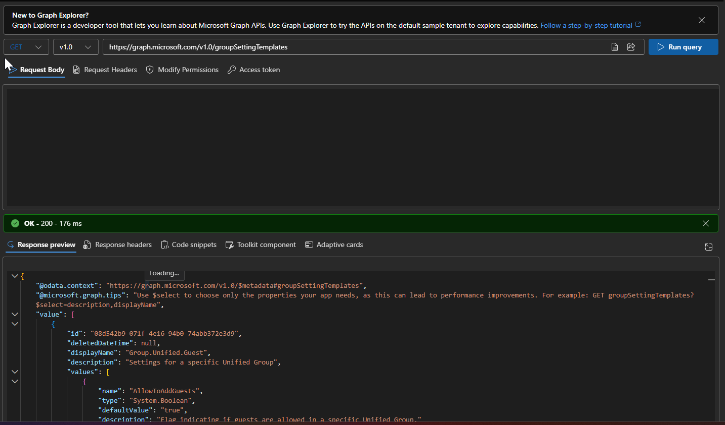
Image: Querying the groupSettingTemplates endpoint.
It will return a long list of templates. You need to scroll through the response and find the one named exactly "Group.Unified" (do NOT confuse it with Group.Unified.Guest).
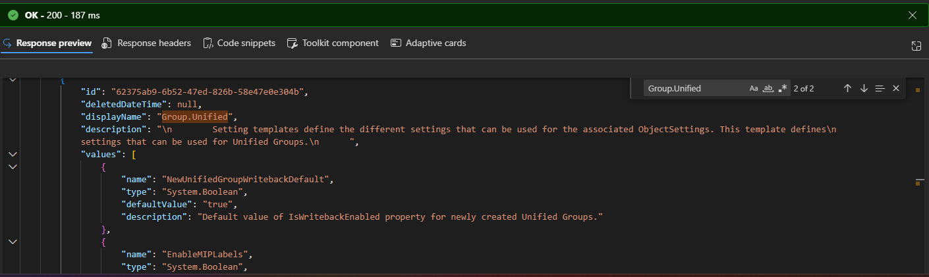
Image: Identifying the 'Group.Unified' template in the JSON response payload.
Once you find it, extract its "id", which usually looks like this:
62375ab9-6b52-47ed-826b-58e47e0e304b
This is the Template ID. It acts as a blueprint to create your specific tenant configuration in the next steps.

Step 4: Check if a Rule is Already Applied
To avoid errors, check if your organization already has a configuration created from that template.
Execute this in Graph Explorer:
GET https://graph.microsoft.com/v1.0/groupSettings
If your screen returns an empty "value": [], it means no configuration exists yet.
However, in our case, you might see that a configuration is already created for Group.Unified:
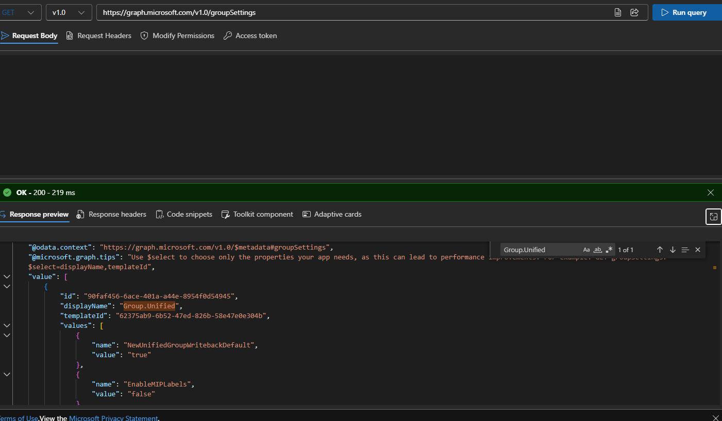
Image: A response showing that a groupSettings configuration already exists.
Check that the templateId matches the one we extracted in Step 3. You must also copy the new "id" of this specific configuration. This is your Configuration ID, not the template ID!
- If no configuration exists -> Proceed to Step 5.
- If a configuration already exists -> Skip Step 5 and proceed directly to Step 6.

Step 5: Create a New Configuration
If no previous configuration exists, you must create one.
Change the method dropdown to POST and execute:
POST https://graph.microsoft.com/v1.0/groupSettings
In the "Request body" tab, paste the following JSON.
Note: Replace the Template ID if yours was different, and insert your Group ID from Step 2 if you want to allow exceptions.
{
"templateId": "62375ab9-6b52-47ed-826b-58e47e0e304b",
"values": [
{ "name": "EnableGroupCreation", "value": "false" },
{ "name": "GroupCreationAllowedGroupId", "value": "9860c313-b518-4563-a6e3-0de7952319b3" }
]
}
- templateId = The specific template blueprint ID (from Step 3).
- value under GroupCreationAllowedGroupId = The group ID of your officers/leaders (from Step 2).
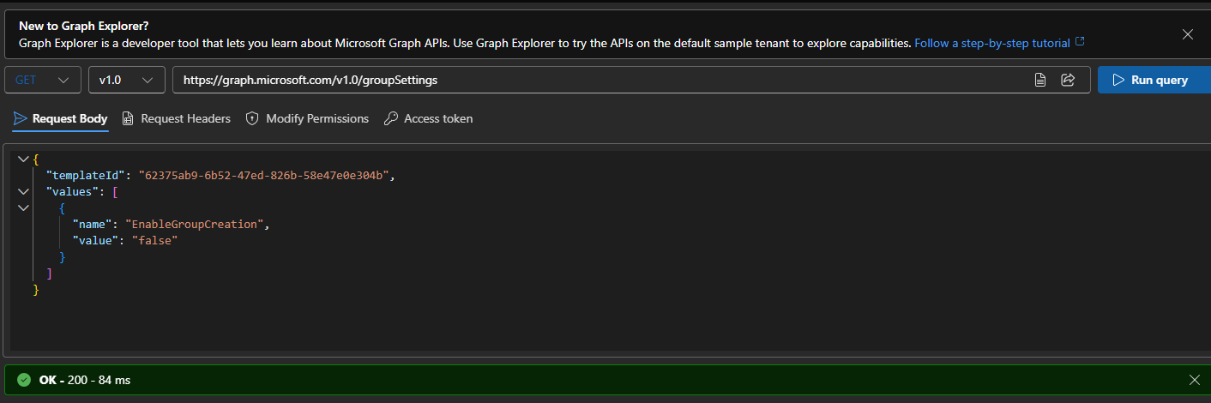
Image: Executing the POST request with the JSON payload in the request body.
Image: The successful response after creating the new configuration.

Step 6: Update an Existing Configuration (The Correct Method)

Important
Why Update (PATCH) instead of making a new one?
Microsoft only allows ONE saved rule for group creation in the entire tenant. If you try to create a new one (Step 5) when one already exists, you will get an error. The safest standard practice is to take the existing rule and inject the new values into it. This is called a "PATCH".
If in Step 4 you discovered that a configuration is already saved for Group.Unified, follow these EXACT steps to add the Leadership Group as an exception:

1. Change the Method to PATCH
At the top left of the Graph Explorer address bar, click on the method dropdown (GET or POST) and select PATCH from the list.

2. Type the Exact URL Address
In the address bar, paste the following path, adding the Configuration ID you grabbed in Step 4 at the very end:
https://graph.microsoft.com/v1.0/groupSettings/YOUR_CONFIGURATION_ID_HERE
For example, using the image from Step 4, the URL should look exactly like this:
https://graph.microsoft.com/v1.0/groupSettings/88888888-9999-aaaa-bbbb-ccccddddeeee
(Make sure to use your actual Configuration ID, not the dummy one from this example).

3. Prepare the "Request Body"
Below the address bar, find the tab labeled "Request body". Click on it, clear everything inside, and paste the exact code below.
CAREFULLY: Replace the text YOUR_GROUP_ID_HERE with the ID of the CF_Lideres group we calculated in Step 2 (9860c313-b518-4563-a6e3-0de7952319b3).
This tells Microsoft: "Block everyone (false), EXCEPT this group":
{
"values": [
{ "name": "EnableGroupCreation", "value": "false" },
{ "name": "GroupCreationAllowedGroupId", "value": "YOUR_GROUP_ID_HERE" }
]
}

4. Execute the Command
Before clicking run, double-check these three things:
- The left button says PATCH.
- The URL ends with the Configuration ID (From Step 4).
- The Request Body contains the Group ID (From Step 2).
Press the large blue button "Run query".
If everything went perfectly, the bottom screen will show a green text message saying No Content - 204 (or similar). Congratulations, the rule has been updated properly to allow that specific group without breaking the tenant-wide block!

Step 7: Verification Process
To ensure everything took effect, run this query again:
GET https://graph.microsoft.com/v1.0/groupSettings
Check the response values to confirm:
- EnableGroupCreation = false
- GroupCreationAllowedGroupId = 9860c313-b518-4563-a6e3-0de7952319b3

Step 8: How to Revert the Restriction
If you ever need to lift the ban and allow all users to create groups/sites freely again:
- Identify your current <CONFIGURATION_ID> by running GET https://graph.microsoft.com/v1.0/groupSettings.
- Change the method to PATCH and use this URL:
PATCH https://graph.microsoft.com/v1.0/groupSettings/<CONFIGURATION_ID>
- In the Request Body, send this payload to toggle creation back to true:
{
"values": [
{ "name": "EnableGroupCreation", "value": "true" }
]
}
- Click Run Query.
Alternatively, you can just change the method to DELETE and run it on the same URL to completely wipe custom configurations and revert to Microsoft's factory defaults.

Step 9: Field Test Verification
To confirm the block works for regular users, perform these tests with a non-admin account:

Test 1: Microsoft Teams
- Log into teams.microsoft.com with a standard user account.
- Navigate to the "Teams" tab on the left margin.
- Expected result: The "+ Join or create a team" button shouldn't allow the creation of new teams.

Test 2: SharePoint Online
- Log into your organization's SharePoint home portal.
- Expected result: The "+ Create site" button should be hidden or disabled.

Test 3: Outlook Web
- Log into outlook.office.com.
- Scroll down to the "Groups" section in the left navigation menu.
- Expected result: The option to create a "New group" should not appear.

Test 4: Administrator Check
- Log into the M365 Admin Center with an Admin account.
- Go to Teams & groups -> Active teams & groups.
- Expected result: IT administrators can still provision groups securely from here.

